# **Fast Separation of Direct and Global Components of a Scene**

# **using High Frequency Illumination**

|  |  |
| --- | --- |
| Xiangming Ka  Carnegie Mellon University |  |

**Abstract**

*When a scene is lit by a source of light, the radiance of each point in the scene can be viewed as having two components, namely, direct and global. An efficient separation method has been proposed that uses high frequency illumination patterns to measure the direct and global components of a scene. We present the theory and implementation details of the fast methods for separating the direct and global illumination components of a scene measured by a camera and illuminated by a light source. In theory, the separation can be achieved with just two images taken with a high frequency illumination pattern and its complement [1]. However, due to the optical and resolution limitations of the camera and the light source, a larger number of images are used in the separation process. We present results using different binary illumination patterns and discuss how we approach to the suitable pattern for the separation process. The global component could arise from not only interreflections but also subsurface scattering within translucent surfaces and volumetric scattering by participating media. We present separation results for scenes that include complex interreflections, subsurface scattering and volumetric scattering, which provide interesting insights into the scattering properties of common real-world materials. We also present how novel images of a scene can be computed from the separation results. In addition, we present method of achieving separation of a static scene that is lit by a simple point source using a moving occlude..*

# Introduction

When a scene is lit by a source of light, the radiance of each point in the scene can be viewed as having two components, namely, direct and global. The direct component arises from the direct illumination of the scene point by the light source. The global component results from the illumination of the point due to scattering of light from other points in the scene. The global illumination can result from a variety of effects, including, interreflections, subsurface scattering and volumetric scattering.

It is highly desirable to have a method for measuring the direct and global components of a scene, as each component conveys important information about the scene that cannot be inferred from their sum. For instance, the direct component gives us the purest measurement of how the material properties of a scene point interact with the source and camera. Therefore, a method that can measure just the direct component can be immediately used to enhance a wide range of scene capture techniques that are used in computer vision and computer graphics. The global component conveys the complex optical interactions between different objects and media in the scene. We know that it is the global component that makes photorealistic rendering a hard and computationally intensive problem. A measurement of this component could provide new insights into these interactions that in turn could aid the development of more efficient rendering algorithms. Furthermore, measurement of the direct and global components can enable new types of image manipulations that are more faithful to the physical laws that govern scattering [2].

The authors, in collaboration with Michael Grossberg at the City University of New York and Ramesh Raskar at MERL, have proposed efficient methods that use high frequency illumination patterns to separate the direct and global components of a scene lit by a single light source. This approach does not require the scattering properties of the scene points to be known. We only assume that the global contribution received by each scene point is a smooth function with respect to the frequency of the lighting. This assumption makes it possible, in theory, to do the separation by capturing just two images taken with a dense binary illumination pattern and its complement. In practice, due to the resolution limits imposed by the source and the camera, a larger set of images (25 in our setting) is used.

In this paper, we present implementation details of this method and validate its effectiveness. And we also show potential problems encountered in implementing this method. We show several variants of the illumination pattern and we descript the method that seek to minimize the number of images needed for separation. In the case of just a simple point light source, such as the sun, the source cannot be controlled to generate the required high frequency illumination patterns. In such cases, the shadow of a line or mesh occluder can be swept over the scene while it is captured by a video camera.

Finally, we present several simple examples of how novel images of a scene can be computed from the separation results. And we discuss how this method can be incorporated into other scenarios where high frequency illumination patterns are used. We conclude the paper with a discussion on several potential application of this for the future.

# Theory of Fast Separation

## Definitions for Direct and Global Illumination and the Light Source

Consider a surface viewed by a camera and illuminated by a point source, as shown in Figure 1(a). Let us assume that the source generates a set of illumination rays, each ray corresponding to a single source element, as in the case of a digital projector. We assume that each point of the surface could cause a significant scattering event in the direction of the camera if lit by the source. The radiance of a surface point measured by the camera due to such a scattering event is referred to as the *direct component*, $L_{d}$. The exact value of the direct component is determined by the BRDF of the surface point, which can be arbitrary. For our separation method to work, we assume that each camera pixel can observe at most one significant scattering event, i.e. two different source elements cannot produce a direct component along a camera pixel’s line of sight [3].

The remaining radiance measured by the camera pixel is referred to as the *global component*, $L_{g}$. In computer graphics, this term is typically used to denote interreflections – light received by a surface point after reflection by other scene points. Here, we are using a more general definition. In addition to interreflections, the global illumination received by the surface point may be due to volumetric scattering, subsurface scattering or even light diffusion by translucent surfaces. The case of diffusion by a translucent surface works similarly to interreflections. In the case of volumetric scattering, the global component arises from the illumination of the surface point by light scattered from particles suspended in a participating medium. In the case of subsurface scattering, the surface point receives light from other points within the surface medium. Finally, the global component also includes volumetric and subsurface effects that may occur within the camera pixel’s field of view but outside the volume of intersection between the fields of view of the pixel and the source element that produces a significant scattering event at the pixel. These are considered to be global effects as they are not significant scattering events caused by individual source elements. In all cases, the total radiance measured at a camera pixel is the sum of the direct and global components:

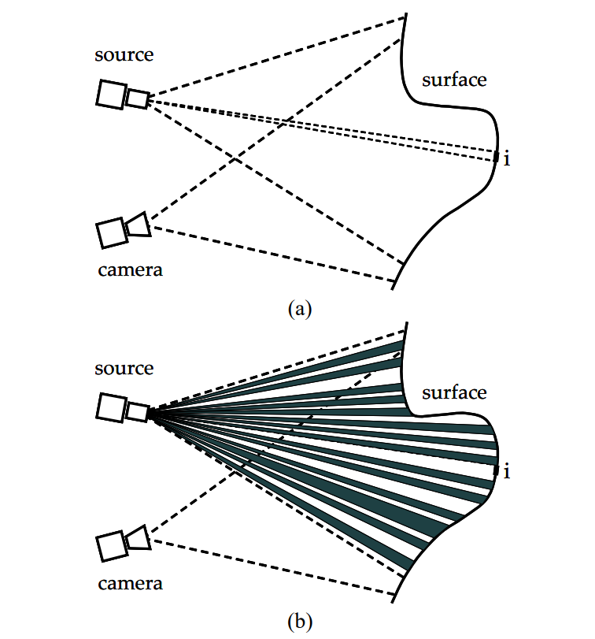

Figure 1: (a) A simple scenario where the radiance of each patch $i$ includes a direct component due to scattering of light incident directly from the source and a global component due to light incident from other points in the scene. (b) When the source radiates a high frequency binary illumination pattern, the lit patches include both direct and global components while the unlit patches have only a global component. In theory, two images of the scene taken with such an illumination pattern and its complement are sufficient to estimate the direct and global components for all patches in the scene.

$L= L_{d}+L_{g}$ (1)

## Separation using High Frequency Illumination

Let us assume that the scene in Figure 1(a) includes a single opaque surface of arbitrary BRDF immersed in a non-scattering medium so that the global component arises solely from interreflections. As we will see, our analysis of this case is applicable to other phenomena such as subsurface and volumetric scattering. Let us divide the surface into a total of N patches, M of which are directly visible to the source. Each of these M visible patches corresponds to a single pixel of the source. We denote the radiance of the patch $i$ measured by the camera c as $L[c,i]$, and its two components as $L_{d} [c,i]$ and $L_{g}[c,i]$, so that $L[c,i] = L_{d} [c,i] + L_{g}[c,i]$. The global component of i due to interreflections from all other surface patches can be written as:

$L_{g}\left[c,i\right]=\sum_{j∈P}{A\left[i, j\right]L\left[i, j\right]},$ (2)

where, $P = \{ j|1 ≤ j ≤ N, j ≠ i\}$. $L[i, j]$ is the radiance of patch $j$ in the direction of patch $i$ and $A[i, j]$ incorporates the BRDF of i as well as the relative geometric configuration of the two patches. We can further decompose $L_{g}[c,i]$ into two components as $L_{g}[c,i] = L_{gd}[c,i] + L_{gg}[c,i]$, where $L_{gd}[c,i]$ is due to the direct component of radiance from all scene patches and $L_{gg}[c,i]$ is due to the global component of radiance from all scene patches:

$L_{gd}\left[c,i\right]=\sum_{j∈P}{A\left[i, j\right]L_{d}\left[i, j\right]}$,

$L_{gg}\left[c,i\right]=\sum_{j∈P}{A\left[i, j\right]L_{g}\left[i, j\right]}.$ (3)

Now let us assume that only a fraction α of the source pixels are activated and that these activated pixels are well-distributed over the entire scene to produce a high frequency illumination pattern, as shown in Figure 3(b). The set of illuminated patches can be denoted as $Q = \{k|k ∈ N$ and $lit(k) = 1\}$, where the function *lit* indicates whether a patch is illuminated or not. Then, the above components become:

${L_{gd}}^{+}\left[c,i\right]=\sum_{j∈Q}{A\left[i, j\right]L_{d}\left[i, j\right]}$,

${L_{gg}}^{+}\left[c,i\right]=\sum_{j∈P}{A\left[i, j\right]{L_{g}}^{+}\left[i, j\right]}.$ (4)

Note that ${L_{gd}}^{+}\left[c,i\right]$ differs from $L_{gd}\left[c,i\right]$ only in that the lit $αM$ patches rather than all the $M$ patches have a direct component and hence make a contribution. Therefore, if the geometry and reflectance term $A[i, j]$ and the direct component $L_{d} [c,i]$ are smooth with respect to the frequency of the illumination pattern, we have:

${L_{gd}}^{+}\left[c,i\right]={αL}_{gd}\left[c,i\right].$ (5)

A brief frequency domain analysis of the illumination frequency that makes the above relation valid is given in Appendix A.

Now, let us consider the second term, ${L_{gg}}^{+}\left[c,i\right]$. Since ${L_{g}}^{+}\left[i, j\right]$ in Equation (4) is the result of higher orders of inter-reflection than ${L_{gd}}^{+}\left[c,i\right]$, it is even smoother and hence less affected by the nonuniformity of the illumination. However, it is directly proportional to the average power of the illumination, which is reduced by $α$ in the case of the high frequency pattern. Therefore, ${L_{g}}^{+}\left[c,i\right]={αL}_{g}\left[c,i\right]$ and we get:

${L_{gg}}^{+}\left[c,i\right]={αL}_{gg}\left[c,i\right].$ (6)

Consider two captured images of the scene, where, in the first image $L^{+}$ the scene is lit with high frequency illumination that has fraction $α$ activated source pixels and in the second image $L^{-}$ it is lit with the complementary illumination that has fraction $1-α$ activated source pixels. If the patch $i$ is lit directly by the source in the first image, then it is not lit by the source in the second image, and we get:

$L^{+}\left[c,i\right]=L_{d}\left[c,i\right]+{αL}_{g}\left[c,i\right]$,

$L^{-}\left[c,i\right]=(1-α)L_{g}\left[c,i\right].$ (7)

Therefore, if we know $α$, we can compute the direct and global components at each camera pixel from just two images. Thus far, we have assumed that when a source pixel is not activated it does not generate any light. In the case of a projector, for example, this is seldom completely true. If we assume the brightness of a deactivated source element is a fraction $b$, where $0 ≤ b ≤ 1$, of an activated element, then the above expressions can be modified as:

$L^{+}\left[c,i\right]=L_{d}\left[c,i\right]+{αL}_{g}\left[c,i\right]+b(1-α)L_{g}\left[c,i\right]$,

$L^{-}\left[c,i\right]=bL_{d}\left[c,i\right]+\left(1-α\right)L_{g}\left[c,i\right]+{αbL}_{g}\left[c,i\right].$ (8)

Again, if $α$ and $b$ are known, the separation can be done using just two images. Note that if $α$ is either close to 1 or 0, the scene will be lit (sampled) very sparsely in one of the two images. Since we wish to maximize the sampling frequency of the illumination in both images, a good choice is $α = \frac{1}{2}$. In this case, we get:

$L^{+}\left[c,i\right]=L_{d}\left[c,i\right]+(1+b)\frac{L_{g}\left[c,i\right]}{2}$,

$L^{-}\left[c,i\right]=bL_{d}\left[c,i\right]+(1+b)\frac{L_{g}\left[c,i\right]}{2}.$ (9)

Based on the above results, we will develop a variety of separation methods. In each case, we will record a set of brightness values at each camera pixel and use $L_{max}$ and $L_{min}$ to denote the maximum and minimum of these values. In the above case of two images taken with $α = \frac{1}{2}$, $L^{+}≥L^{-}$ and hence $L_{max}= L^{+}$ and $L_{min}= L^{-}$ [1].

# Verification and Limitations

## Verification

We present several verification results on the use of high frequency illumination for estimating the direct and global components. For these experiments, we used the scene shown in Figure 2(a) that includes a wide variety of physical phenomena. The scene was lit by a DBPOWER 9500L digital projector (with 1920 × 1080 pixels) and images were captured using a Canon 80D camera (with 6000 × 4000 pixels).



Figure 2: (a) Scene used for the verification experiments, which contains diffuse, specular, and subsurface scattering objects. (b) Separated direct component of the scene using this method. (c) Separated global component of the scene using this method.

(a)

In this experiment, we used mosaiced images downsampled to 1920 × 1280 pixels to reduce noise. And we used square patches of size 8 × 8 pixels in projector to construct the high frequency pattern. We shifted the pattern 6 times (by 3 pixels each time) in each of the two dimensions.

In the first experiment, we a scene that contains a wide variety of physical phenomena to study the effectiveness of this separation method. The result of this experiment includes diffuse interreflection on the paper package, specular interreflections due to the coffee can, and subsurface scattering in the stuffed toys. This demonstrated our implementation successfully yields reasonable results using this separation method.

To further study the material properties using this separation method, Figures 3(a)-(c) show separation results for several scenes where each scene has a dominant phenomenon that produces that global illumination. In Figure 3(a) the global image includes the strong specular interreflections due to the metal coffee can. In Figure 3(b) the appearance of the stuffed toys and grapes is dominated by subsurface scattering, as seen from the global image. The direct component mainly includes specular reflections from the surface. In Figure 3(c) the global image mainly contains refraction and caustic effects due to the transparent objects. It also shows volumetric scattering in the glass cup. And the direct image is dominated by diffuse and specular reflections from the surface.

## Limitations

In these experiments, we encountered several limitations of this separation method. The first limitation is the illumination frequency. When the frequency is not sufficiently high, the separation method will not be able to produce accurate results. For example, if the scene includes highly specular or refractive surfaces, the surface point may be strongly illuminated from multiple directions and hence exhibit multiple significant scattering events as shown in Figure 4(a). However, due to light leakages within the projector optics and custom image processing incorporated by the manufacturer, the lit and unlit checkers have brightness variations within them. Furthermore, due to the limited depth of field of the projector, the checkers can be defocused in some scene regions [1]. Figure 4(b) shows the light leakages due to projector optics and Figure 4(c) shows the results produced by insufficient illumination frequency patterns. In this case, we only shifted the pattern 2 times (by 4 pixels each time) in each of the two dimensions. The variation of brightness within pixels introduced noticeable artifacts to the separation results. To overcome these problems, we take a larger number of images than the theory requires. In our experiments, we used a pattern with checkers that are 8×8 pixels in size and shifted the pattern 6 times (by 3 pixels each time) in each of the two dimensions to capture a total of 36 images. We will discuss the illumination pattern and how we approach to choose the ideal pattern in detail in Section 4.

(c)

(b)

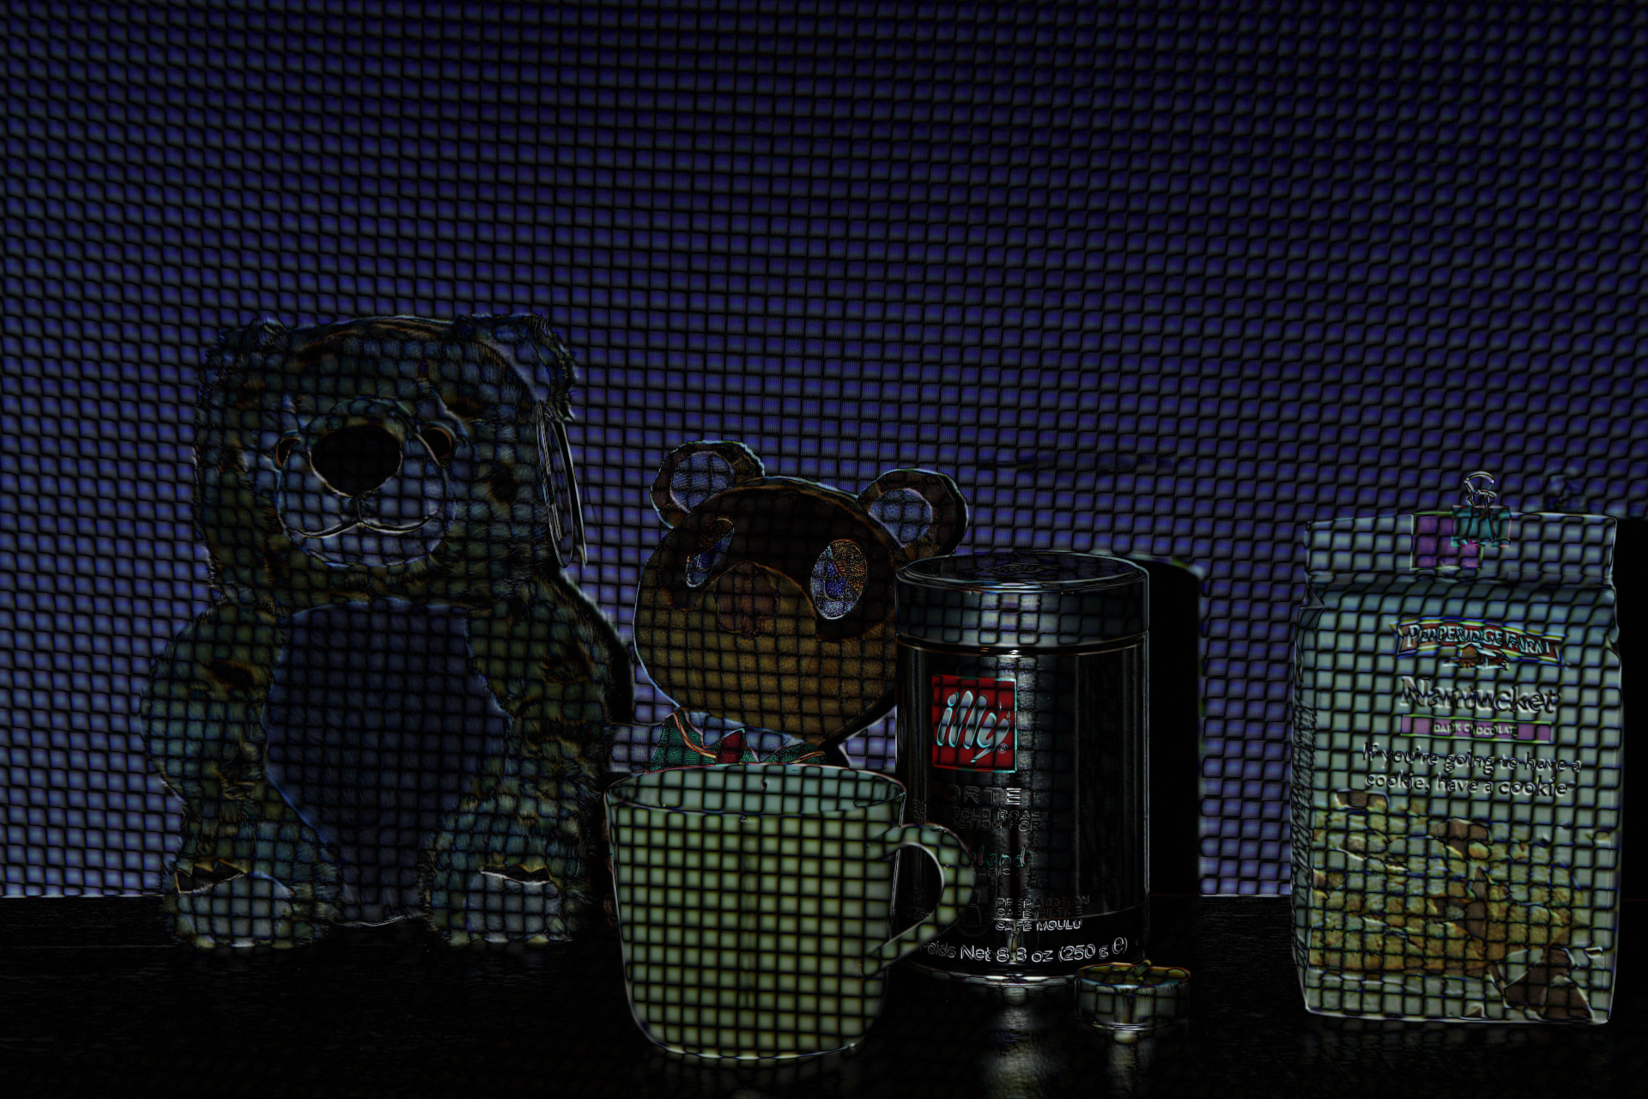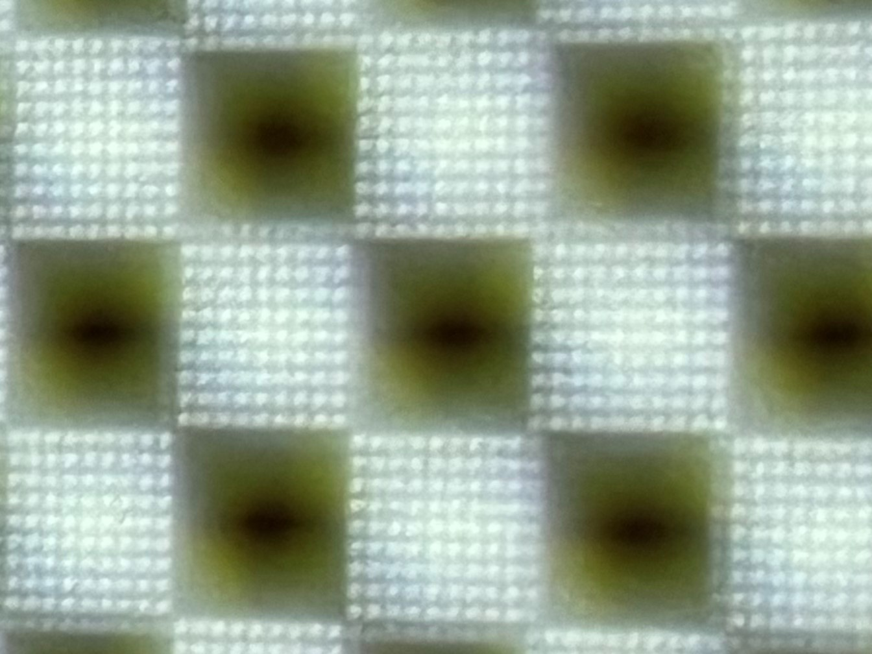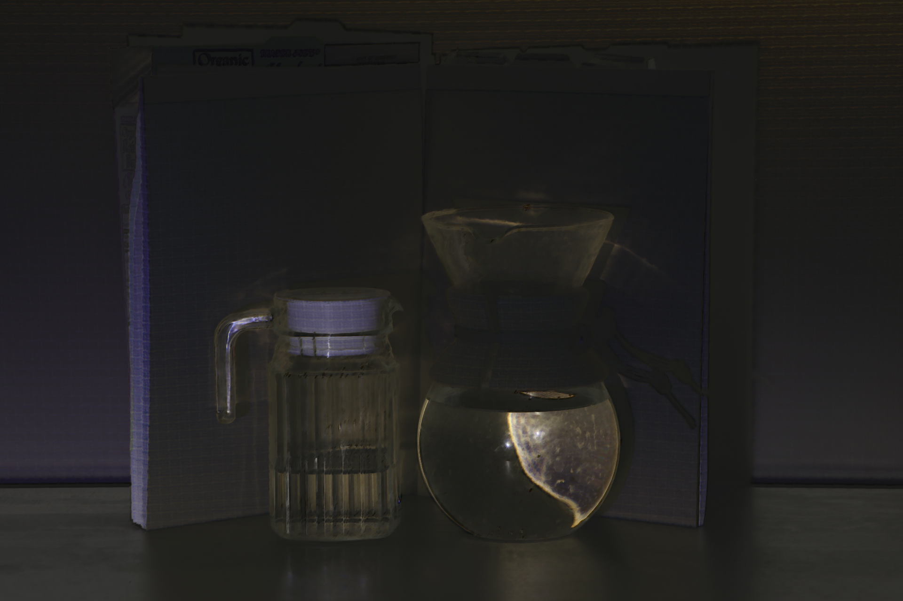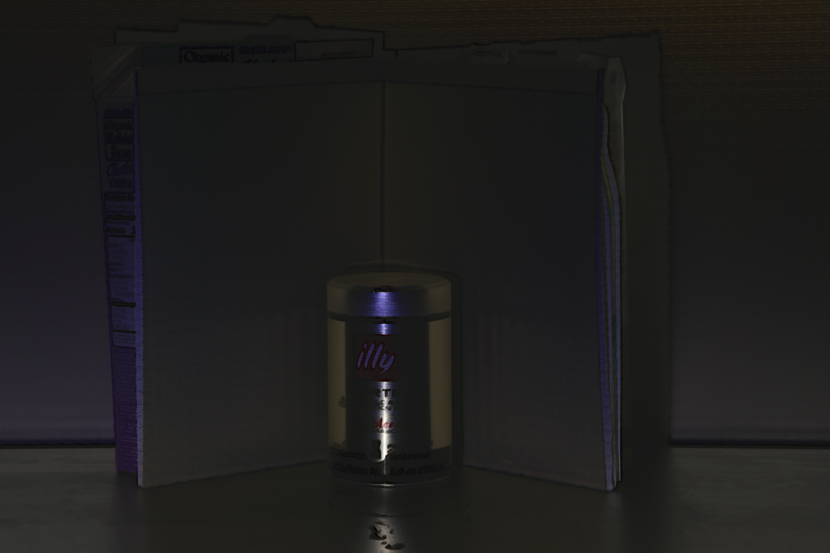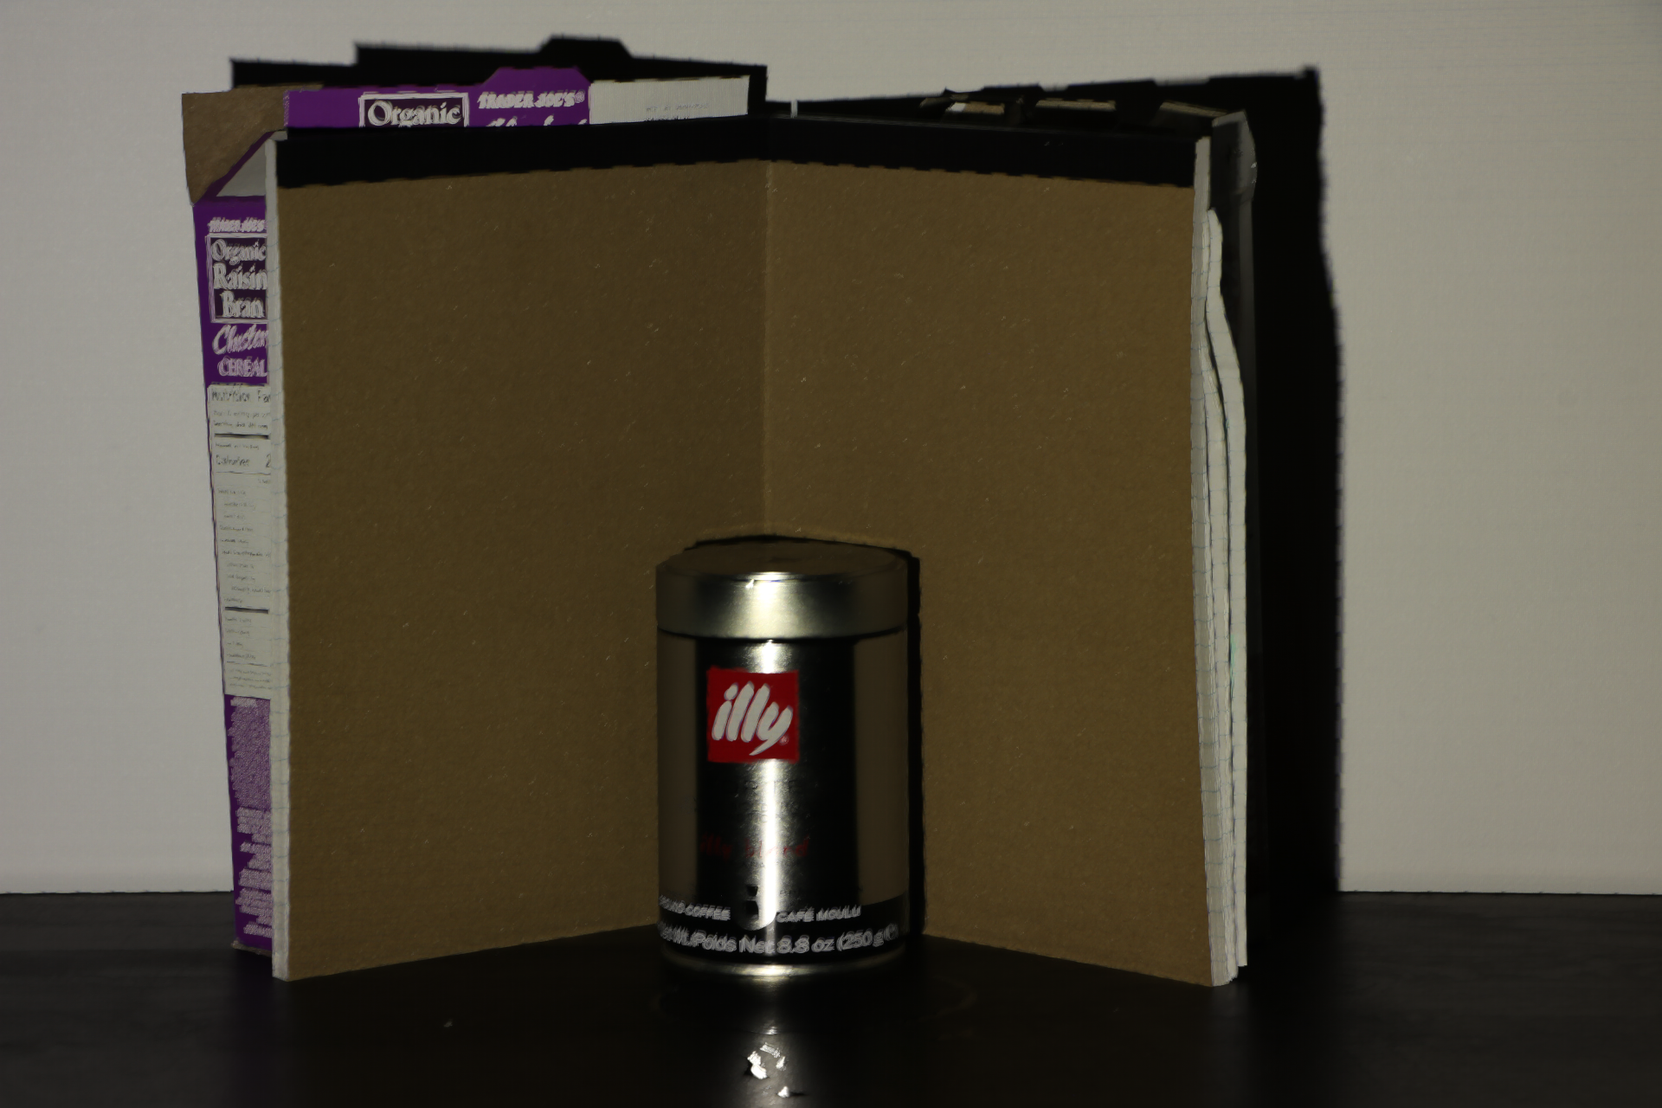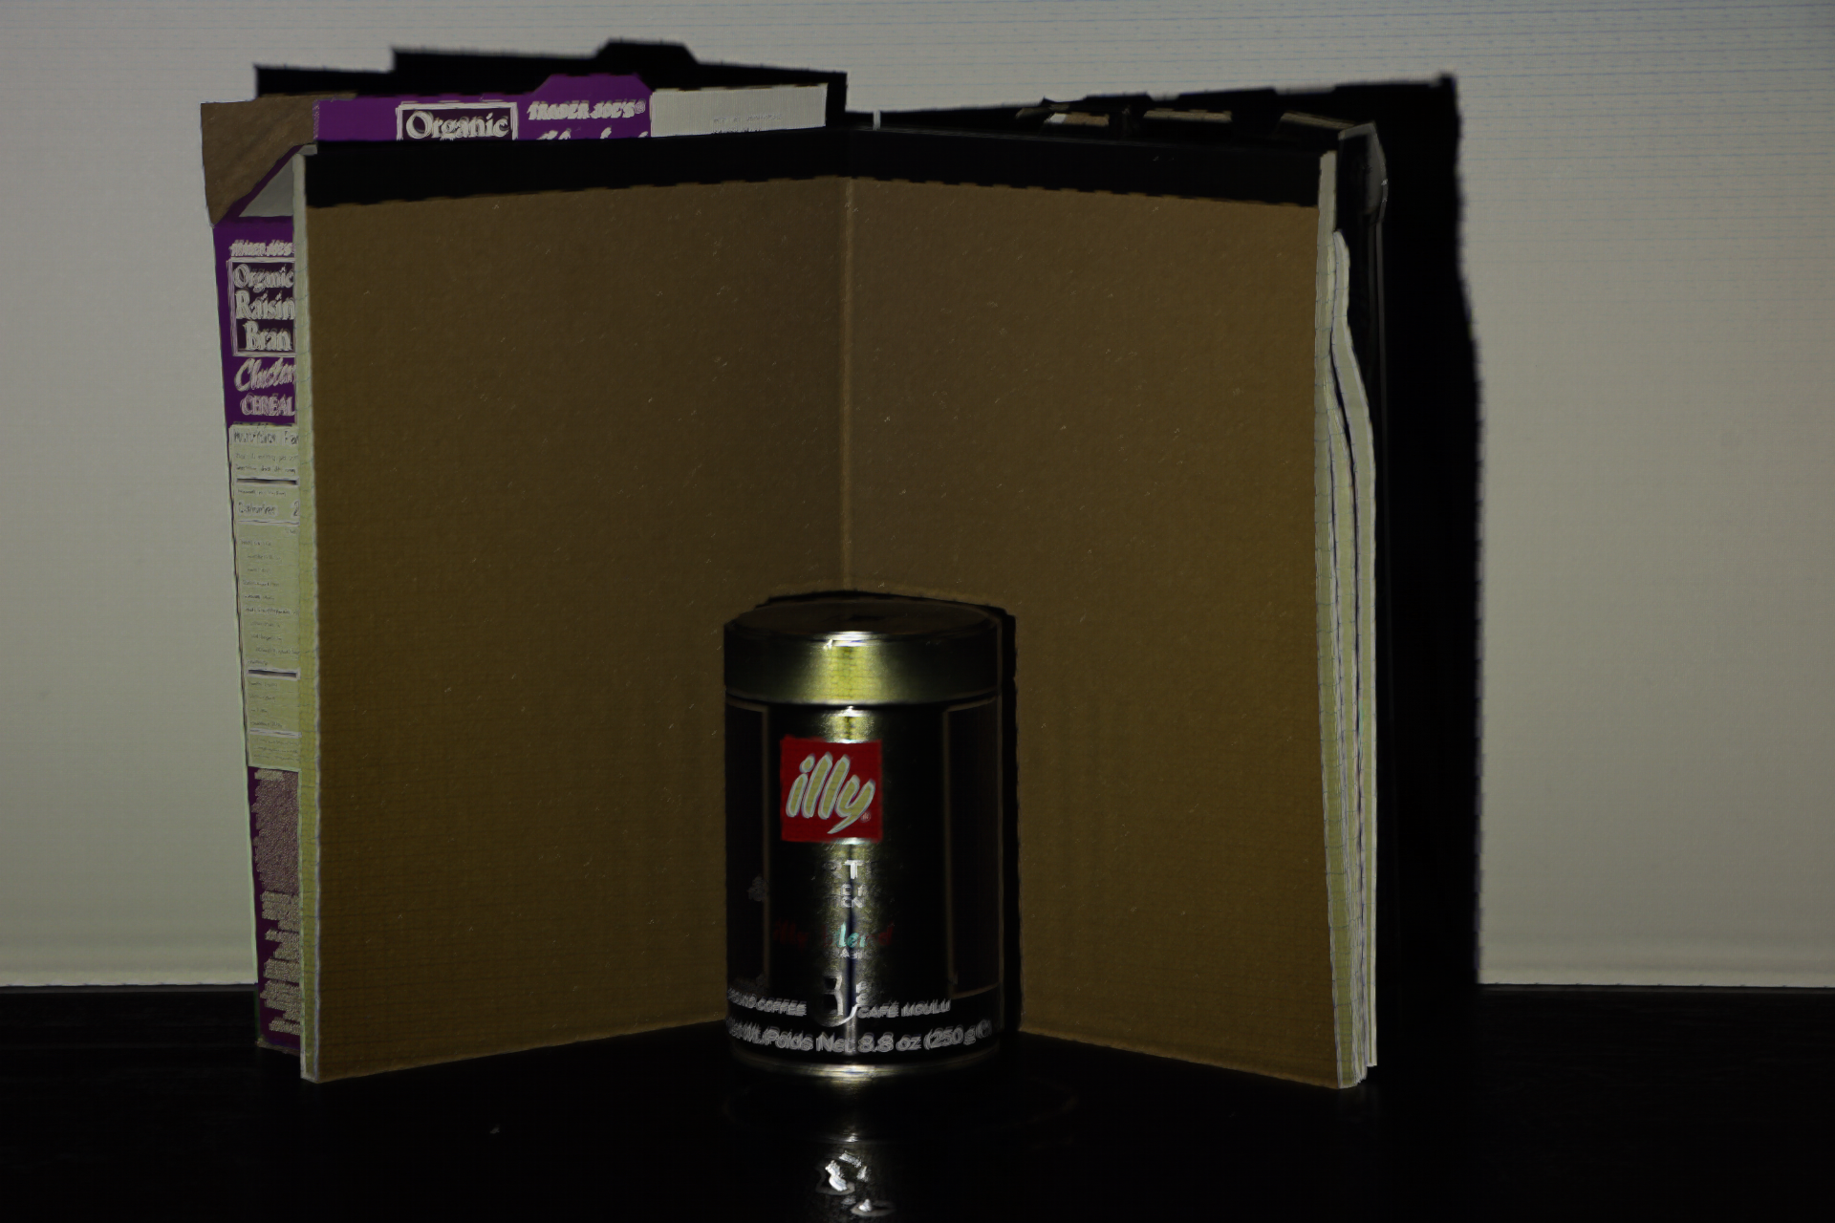

(c)

(b)

(a)

**Global Component**

Figure 4: (a) Global component of separation results in a scene includes highly specular surface. The separation method fails in this case as the scene violates our assumption that the global function at each point is smooth compared to the illumination frequency. As a result, we see strip-like artifacts in the measured global image. (b) Light leakages due to projector optics. (c) Global component of separation results produced by insufficient illumination frequency patterns.

Figure 3: Separation results for different scenes, each with a dominant physical phenomenon that produces the global component. (a) A scene with a metal coffee can and card boards that includes specular interreflections. (b) A scene with stuffed toys and grapes that includes subsurface scattering. (c) A scene with glass cups that produce caustics, refractions, and Volumetric Scattering.

(c) Glass Cups: Transparent and Volumetric Scattering

(b) Stuffed Toys and Grapes: Subsurface Scattering

1. Metal Coffee Can: Specular Interreflections

**Direct Component**

**Scene**

# Separation Methods and Novel Images

Figure 5: (a) Captured images using a set of shifted checkerboard illumination patterns. (b) $L_{max}$ computed using this method. (c) $L_{min}$ computed using this method.

## Checkerboard Illumination Shifts

As we discussed in Section 2, in theory, a high frequency illumination pattern and its complementary are sufficient to obtain the direct and global components of a scene. Unfortunately, it is difficult to obtain such ideal patterns using an off-the-shelf digital projector. Due to light leakages within the projector optics and custom image processing incorporated by the manufacturer, the lit and unlit checkers have brightness variations within them. Furthermore, due to the limited depth of field of the projector, the checkers can be defocused in some scene regions as shown in Figure 4(b). After experimenting with different checkerboard size (6×6, 8×8, 10×10, etc.), we found that the minimum size that is sufficient to produce reasonable result is 8×8 pixels in the projector. And we experimented with different shift amount (by 2, 3, 5 pixels each time), in which we found that shifting 2 pixels each time for 6 times produces reasonable results while taking least shift times. To achieve the result, we need to capture a total of 36 images. The separation steps are illustrated in Figure 5, where the images correspond to the scene in Figure 1. At each pixel, the maximum and minimum measured brightnesses $(L_{max},L_{min})$ were used to compute the direct and global estimates $(L_{d} ,L_{g}$) using Equation 9.

(a)

## Source Occluders

(b)

As the separation method only needs captured images of a scene partially lit by high frequency illumination, occluders of various kinds can be used to cast high frequency shadows on the scene. For example, a line occluder, such as the stick in Figure 5(b), can be swept across the scene while it is captured by a video camera. If the occluder is thin, its shadow will occupy a small part of the scene and hence we can assume $α = 1$ in Equation (8). Furthermore, if the scene point lies within the umbra of the shadow there will be no direct contribution due to the source and hence $b = 0$ in Equation 8. Let $L_{max}$ and $L_{min}$ be the maximum and minimum brightnesses observed at a scene point in the video captured while sweeping the occluder. Then, $L_{max}= L_{d} +L_{g}$, $L_{min}=L_{g}$ and the two components can be computed [1].

(c)

## Other High Frequency Patterns

Based on the theory in Section 2, other high frequency illumination patterns are applicable to this separation method. It can be easily incorporated into standard structured-light range finders that use coded illumination patterns. In the case of binary coded patterns, some of the patterns will have high frequency stripes [4]. The corresponding images can be used to estimate the direct and global components. Figure 7 shows the scene in Figure 6 that is lit by binary strip illumination patterns.

(c)

(b)

(a)

(a)

Figure 7: Scene lit by binary strip illumination patterns that can be used in structured-light range finders

## Novel Images

With the direct and global images computed from separation, we can adjust the weight of the direct and global components to form a novel image. Although such an image appears unrealistic and is impossible from a physical standpoint, it is interesting as it emphasizes the optical interactions between objects in the scene. In Figure 8(a), the grapes have been given different colors by changing their hues in the global image and recombining with the direct image, which includes the specular high-lights that have the color of the source.

(b)

(c)

Figure 8: Novel images computed from the separation results.

(b)

(a)

Figure 6: (a) Captured image using a line occluder (stick) to scan scenes lit by a simple source (b) Separated direct component of the scene using this method. (c) Separated global component of the scene using this method.

# Discussion

In this paper, we present the theory of direct and global component separation from Michael Grossberg and Ramesh Raskar. We experiment with different high frequency illumination patterns to produce the final results. In this experiment process, we encountered several limitations due to the light leakages within the projector optics. To reduce the artifacts, we present our illumination pattern configuration to produce reasonable results. We also experiment with different shape of the illumination pattern and used source occluers to generate high frequency shadows of the scene. With the separated direct and global images, we present a set of images that contain a wide variety of physical phenomena including diffuse interreflection, specular interreflections, subsurface scattering, and volumetric scattering. We are also able to create novel images that have different weight of the direct and global component of the scene. This separation method also provides possibilities of incorporating into other scenarios where frequency illuminations are applied like standard structured-light range finders.

Most importantly, with the separated direct and global component of the scene, we are able to study the complicated scattering property of materials, with is valuable in the field of computer vision and computer graphics [5]. This method can be used to study the BRDFs and BSSRDFs of material based on direct and global images.

# References

1. S.K. Nayar, G. Krishnan, M.D. Grossberg, and R. Raskar. Fast Separation of Direct and Global Components of a Scene using High Frequency Illumination ACM Transactions on Graphics (also Proc. of ACM SIGGRAPH), Jul. 2006
2. S.K. Nayar and G. Krishnan. Visual Chatter in the Real World. Eurographics Symposium on Rendering. Jun. 2006
3. KAJIYA, J. T. The Rendering Equation. In Proc. of SIG GRAPH, ACM Press, New York, NY, USA, 143–150.
4. ARIKAN, O., FORSYTH, D., AND O’BRIEN. Fast and detailed approximate global illumination by irradiance decomposition. ACM Trans. on Graph. 24, 3, 1108–1114.
5. HANRAHAN P., KRUEGER W.: Reflection from Layered Surfaces due to Subsurface Scattering. In Proc. of SIGGRAPH (1993), ACM Press, pp. 165–174.